6th May 2016

**FIA WTCC - Eyes set on Marrakech**

With the FIA World Touring Car Championship Race of Morocco at the weekend, and a third of the Championship nearly gone, the North African Royal City could witness some of the most exciting races this season so far.

With special elements such as the local hero Mehdi Bennani, currently doing extremely well and placed in third overall in the drivers ranking, home support could be a very important factor for him to give the Sebastian Loeb Racing Team more glory at the weekend.

The battle of the big 2 works teams, Honda and Citroen has taken an interesting turn this year, with Honda having fine tuned their car to make it more competitive than last season and already showing great results and victories and really challenging for the title.

The Circuit Moulay El Hassan, located in the heart of Marrakech, has also been transformed from a street circuit into a semi-permanent race track designed by Hermann Tilke’s renowned architecture agency and built to FIA Grade II standards. While the layout retains the Atlas Mountains and the Marrakech city wall as its backdrop, the length has been reduced from 4.6 kilometres to three kilometres.

“As Official Tyre suppliers to the World Championship, YOKOHAMA continues to have its Motorsport support team and Engineers ready for the action at every race and looking forward to the thrills of Motorsport racing at the highest levels of competition.” Added David Oliva Communications Manager for YOKOHAMA Europe.

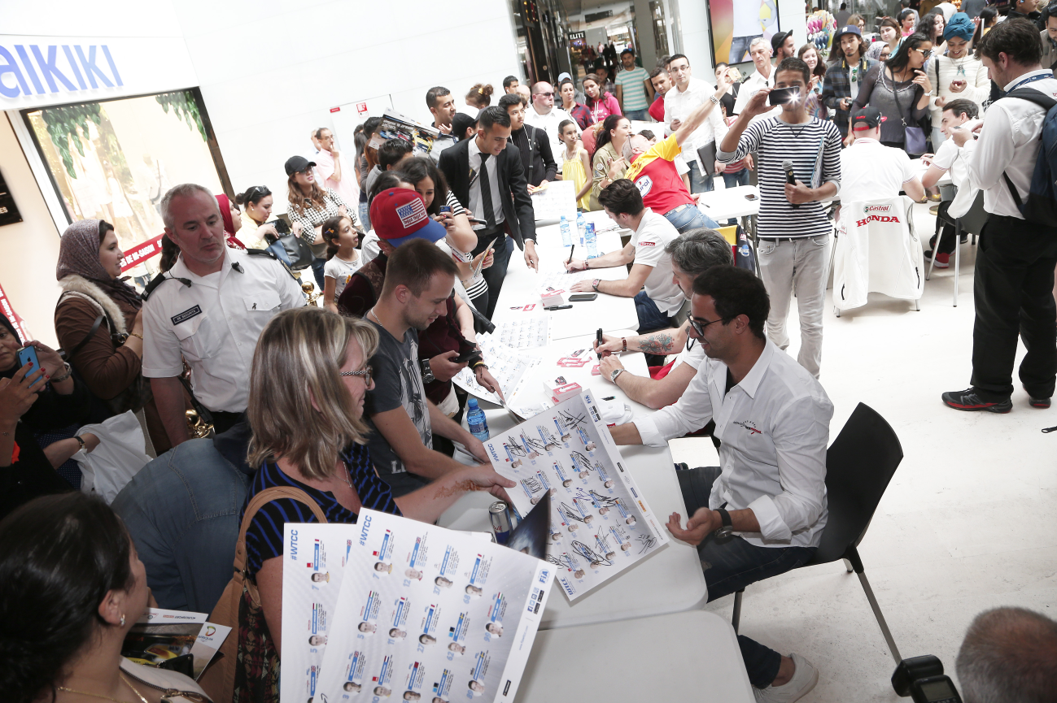

*Warm welcome to WTCC Drivers in Marrakech*

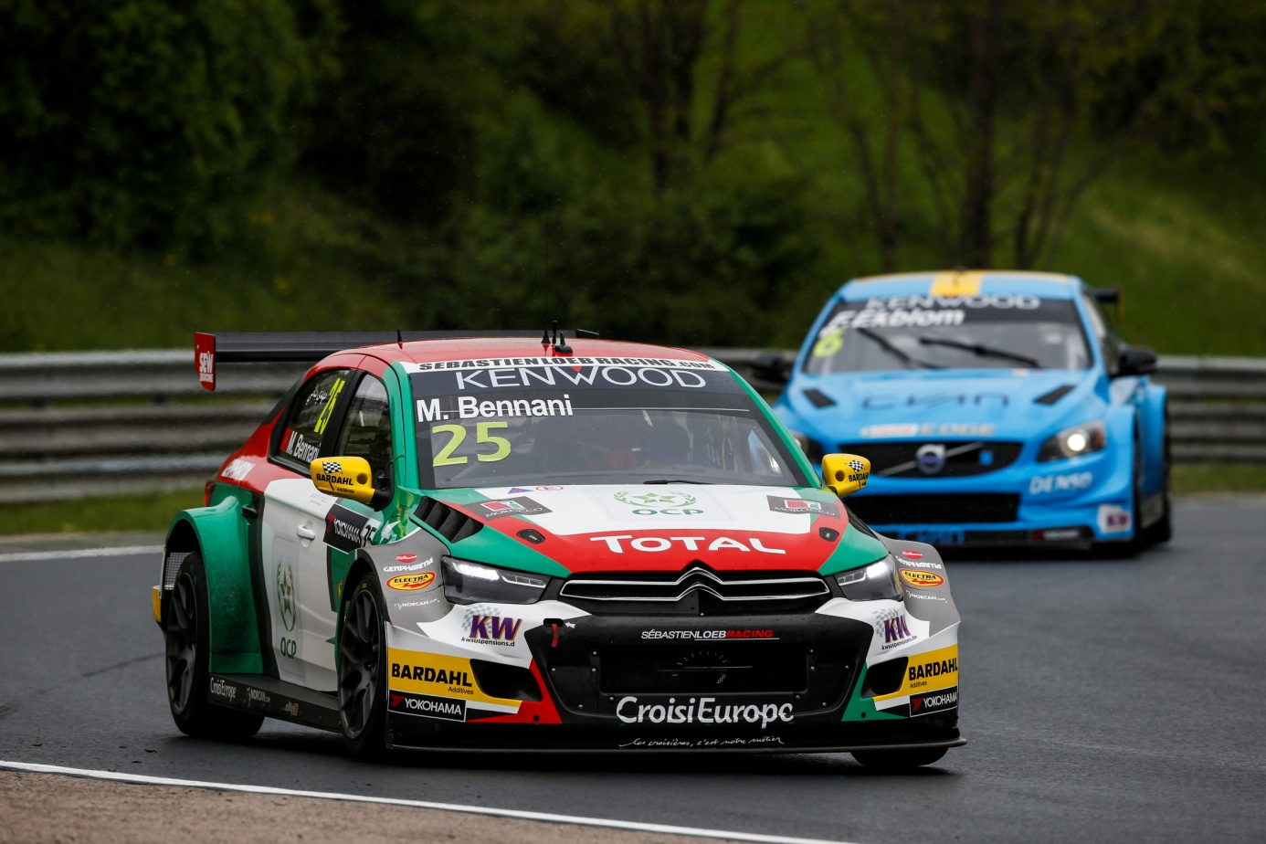

*Homeboy Bennani hopeful for WTCC Race of Morocco*

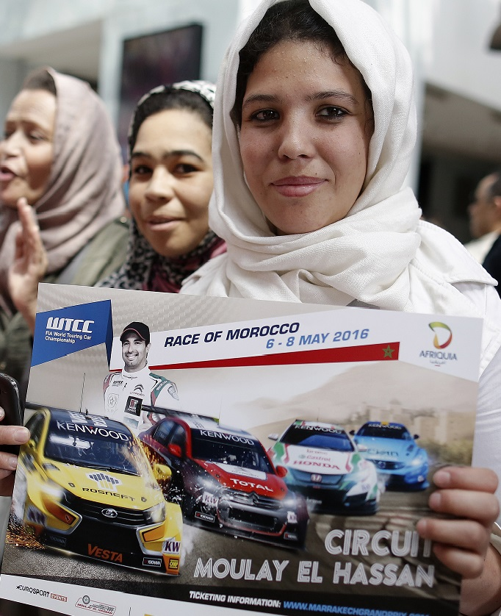

*Race of Morocco*